## Go-Play

In this project, there are three modules first one is Admin, the second one is the captain and the last one is the player. if we talk admin where admin work is to manage all the functions related to the sports, schedule, tournament, booking request, news, and team. Admin creates the team and select captain for the team. And the captain can log in and view game details, he can select player for team and can register sports tournament. now we come in the third one that is a player who can view tournaments result and score .Here admin is the most important part of this sports tournament system because he manages all the events and schedules time of the sports tournament even he decides that playing team members .

Modules

**ADMIN**

1. Approve users.
2. Add & Mange Games.
3. Add & Manage News.
4. Add team
5. select captain
6. Manage user
7. Create and Manage Schedule.
8. Add & Manage Tournament.
9. View Booking and confirm it.
10. Publish result
11. Add individual score.
12. Manage booking cancellation request
13. View Feedback.
14. Generate various report

**USER: Captain**

1. Registration.

Login to Portal.

1. Manage Profile.
2. Add team players
3. Manage team players
4. View Tournament.
5. View Team Details.
6. Booking Tournament. 10.Give Feedback. 11.Booking cancellation

**Player**

1. View Tournament Result.
2. View score.
3. View news, videos.

## TABLES

**Table No** **01**

**Table Name** **: tb_login**

**Primary Key** **: login_id**

**Table Description : To store user Login information**

|  |  |  |  |
| --- | --- | --- | --- |
| **Field Name** | **DataType** | **Constraints** | **Description** |
| login_id | Bigint(20) | PrimaryKey | Login id |
| Username | Varchar(50) | Unique | User name |
| Password | Varchar(20) | Notnull | Password |
| UserType | Varchar(20) | Notnull | User type |
| Status | Int(5) | Notnull | Status |
| approve | Varchar(20) |  | Approve user |

**Table No** **02**

**Table Name** **: tb_ user**

**Primary Key** **: user_id**

**Foreign Key** **: log_id,**

**Table Description: To store user registration information**

|  |  |  |  |
| --- | --- | --- | --- |
| **Field Name** | **DataType** | **Constraints** | **Description** |
| User_id | Int | PK | User id |
| Logid | Int | FK | Tb_login table id |
| Name | Varchar(100) |  | Name of user |
| Mobile | Int |  | Phone number |
| Email | Varchar(50) |  | Email id |
| Place | Varchar(100) |  | Place |
| Sp_type | Varchar(50) |  | Sports type |
| Pt_name | Varchar(100) |  | Previous team name |
| Position | Varchar(100) |  | Position of player |
| Exp | Varchar(100) |  | Experience |
| Eligibility | Varchar(100) |  | Eligibility of player |

**Table No** **03**

**Table Name** **: tb_news**

**Primary Key** **: n_id**

**Table Description: To store News related to tournament**

|  |  |  |  |
| --- | --- | --- | --- |
| **Field Name** | **DataType** | **Constraints** | **Description** |
| News_id | Int(5) | PK | News id |
| Title | Varchar(50) |  | Title of news |
| Description | Varchar(200) |  | News description |

**Table No** **04**

**Table Name** **: tb_tournament**

**Primary Key** **: trmn_id**

**Table Description: To store tournament information**

|  |  |  |  |
| --- | --- | --- | --- |
| **Field Name** | **DataType** | **Constraints** | **Description** |
| T_id | Int(5) | PK | Tournament id |
| T_name | Varchar(100) |  | Tournament name |
| Sports name | Varchar(50) |  | Name sports |
| Place | Varchar(50) |  | Place |
| Stadium | Varchar(50) |  | Name of stadium |
| Time | Time |  | Time |
| Date | Date |  | Date |
| price | Date |  | Registration Fee |

**Table No 05**

**Table Name** :**tb_teams**

**Primary Key** **: team_id**

**Foreign Key** **: user_id**

**Table Description : To store team details**

|  |  |  |  |
| --- | --- | --- | --- |
| **Field Name** | **DataType** | **Constraints** | **Description** |
| team_id | Int(5) | PK | Team id |
| User_id | Int(5) | Fk | tb_user table id |
| Temname | Varchar(100) |  | Name of the team |
| Mobile | Int(15) |  | Mobile number |
| Email | Varchar(50) |  | Email id |
| Place | Varchar(50) |  | Place |
| Status | Int(5) |  | Status of team |

**Table No** **06**

**Table Name** **: tb_Games**

**Primary Key** **: G_id**

**Table Description: To store game details**

|  |  |  |  |
| --- | --- | --- | --- |
| **Field Name** | **Data Type** | **Constraints** | **Description** |
| g_id | Int(5) | PK | game id |
| Name | Varchar(50) |  | Name |
| No of ptc | Int(5) |  | No of participants |
| Rules | Varchar(100) |  | Rules of game |

**Table No** **07**

**Table Name** **: tb_feedback**

**Primary Key** **: f_id**

**Table Description: To store feedback details**

|  |  |  |  |
| --- | --- | --- | --- |
| **Field Name** | **Data Type** | **Constraints** | **Description** |
| F_id | Int | PK | Feedback id |
| User_id | Int | FK | tb_ User table id |
| Feedback | Varchar(100) |  | User feeback |

**Table No**  **09**

**Table Name** **: tb_booking**

**Primary Key** **: booking_id**

**Table Description: To store tournament booking details**

|  |  |  |  |
| --- | --- | --- | --- |
| **Field Name** | **Data Type** | **Constraints** | **Description** |
| Booking_id | Int(10) | PK | Booking id |
| trmn_id | Int(10) | FK | Tb_tournament table id |
| team_id | Int(10) | Fk | Tb_team table id |

**Table No**  **10**

**Table Name** **: tb_teamplayers**

**Primary Key** **: tp_id**

**Table Description: To store team players details**

|  |  |  |  |
| --- | --- | --- | --- |
| **Field Name** | **Data Type** | **Constraints** | **Description** |
| TP_id | Int(10) | PK | Team player id |
| Team_id | Int(10) | FK | Team id from tb_team |
| User_id | Int(10) | FK | User_id from tb_user |
| Status | Int(10) |  | Status |

**Table No**  **12**

**Table Name** **: tb_matchschedule**

**Primary Key** **: ms_id**

**Table Description: To store match schedule details**

|  |  |  |  |
| --- | --- | --- | --- |
| **Field Name** | **Data Type** | **Constraints** | **Description** |
| ms_id | Int(10) | PK | Match schedule id |
| Trmn_id | Int(10) | FK | Tournament id |
| Match | Varchar(50) |  | Match name |
| Team1 | Varchar(50) |  | First Team name |
| Team2 | Varchar(50) |  | Second Team name |

**Table No**  **13**

**Table Name** **: tb_matchscore**

**Primary Key** **: tms_id**

**Table Description: To store match score details**

|  |  |  |  |
| --- | --- | --- | --- |
| **Field Name** | **Data Type** | **Constraints** | **Description** |
| Tms_id | Int | PK | Match score id |
| Ms_id | Int (50) | FK | Match schedule |
| Team1score | Int (50) |  | First team score |
| Team2score | Int (50) |  | Second team score |

**Table No**  **14**

**Table Name** **: tb_score**

**Primary Key** **: score_id**

**Table Description: To store player’s score details**

|  |  |  |  |
| --- | --- | --- | --- |
| **Field Name** | **Data Type** | **Constraints** | **Description** |
| Score_id | Int | PK | Score id |
| Trmn_id | int(10) | FK | Tb_tournament table id |
| Team_id | int(10) | FK | Tb_teams table id |
| User_id | int(10) | FK | Tbuser table id |
| Score | Score(100) |  | Score of player |

**Table No**  **15**

**Table Name** **: tb_bookingpay**

**Primary Key** **: pb_id**

**Table Description: To store payment details**

|  |  |  |  |
| --- | --- | --- | --- |
| **Field Name** | **Data Type** | **Constraints** | **Description** |
| Pb_id | Int(5) | PK | Booking payment id |
| log_id | Int(5) | FK | Login id from tb_login |
| Book_id | Int(5) | FK | Booking id from tb_booking |
| T_amount | Int(50) |  | Amount payment |
| Paystatus | Varchar(20) |  | Payment status |
| Date_added | date |  | Date of payment |

**Table No**  **10**

**Table Name** **: tb_teamplayers**

**Primary Key** **: tp_id**

**Table Description: To store team players details**

|  |  |  |  |
| --- | --- | --- | --- |
| **Field Name** | **Data Type** | **Constraints** | **Description** |
| TP_id | Int(10) | PK | Team player id |
| Team_id | Int(10) | FK | Team id from tb_team |
| User_id | Int(10) | FK | User_id from tb_user |
| Status | Int(10) |  | Status |

**Table No**  **12**

**Table Name** **: tb_matchschedule**

**Primary Key** **: ms_id**

**Table Description: To store match schedule details**

|  |  |  |  |
| --- | --- | --- | --- |
| **Field Name** | **Data Type** | **Constraints** | **Description** |
| ms_id | Int(10) | PK | Match schedule id |
| Trmn_id | Int(10) | FK | Tournament id |
| Match | Varchar(50) |  | Match name |
| Team1 | Varchar(50) |  | First Team name |
| Team2 | Varchar(50) |  | Second Team name |

**Table No**  **13**

**Table Name** **: tb_matchscore**

**Primary Key** **: tms_id**

**Table Description: To store match score details**

|  |  |  |  |
| --- | --- | --- | --- |
| **Field Name** | **Data Type** | **Constraints** | **Description** |
| Tms_id | Int | PK | Match score id |
| Ms_id | Int (50) | FK | Match schedule |
| Team1score | Int (50) |  | First team score |
| Team2score | Int (50) |  | Second team score |

**Table No**  **14**

**Table Name** **: tb_score**

**Primary Key** **: score_id**

**Table Description: To store player’s score details**

|  |  |  |  |
| --- | --- | --- | --- |
| **Field Name** | **Data Type** | **Constraints** | **Description** |
| Score_id | Int | PK | Score id |
| Trmn_id | int(10) | FK | Tb_tournament table id |
| Team_id | int(10) | FK | Tb_teams table id |
| User_id | int(10) | FK | Tbuser table id |
| Score | Score(100) |  | Score of player |

**Table No**  **15**

**Table Name** **: tb_bookingpay**

**Primary Key** **: pb_id**

**Table Description: To store payment details**

|  |  |  |  |
| --- | --- | --- | --- |
| **Field Name** | **Data Type** | **Constraints** | **Description** |
| Pb_id | Int(5) | PK | Booking payment id |
| log_id | Int(5) | FK | Login id from tb_login |
| Book_id | Int(5) | FK | Booking id from tb_booking |
| T_amount | Int(50) |  | Amount payment |
| Paystatus | Varchar(20) |  | Payment status |
| Date_added | date |  | Date of payment |

# UML DIAGRAMS

USE CASE DIAGRAM

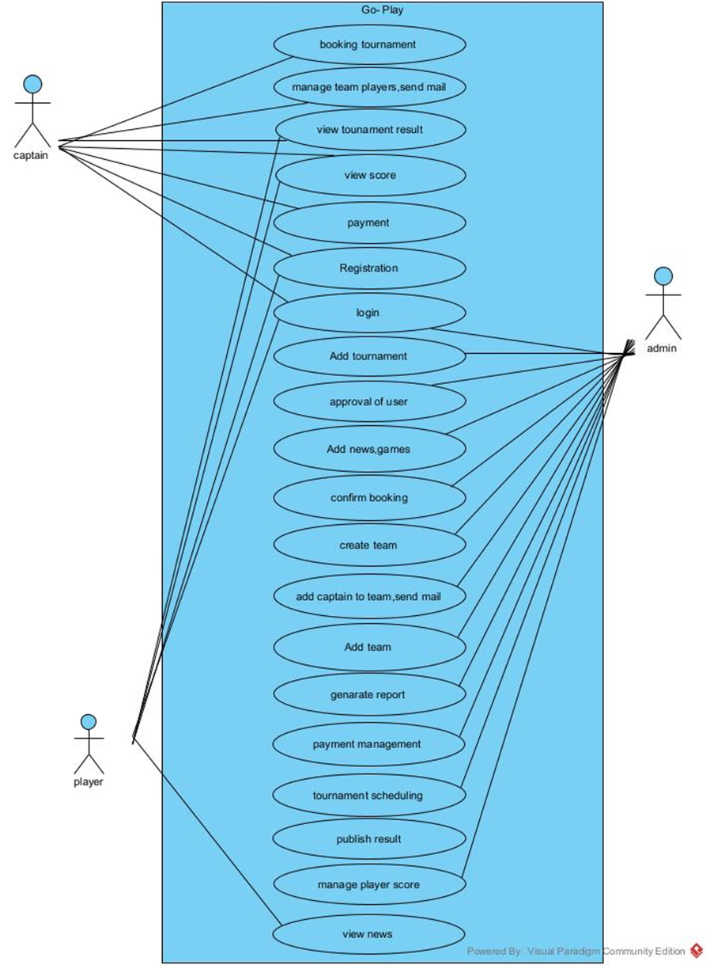

# ACTIVITY DIAGRAM

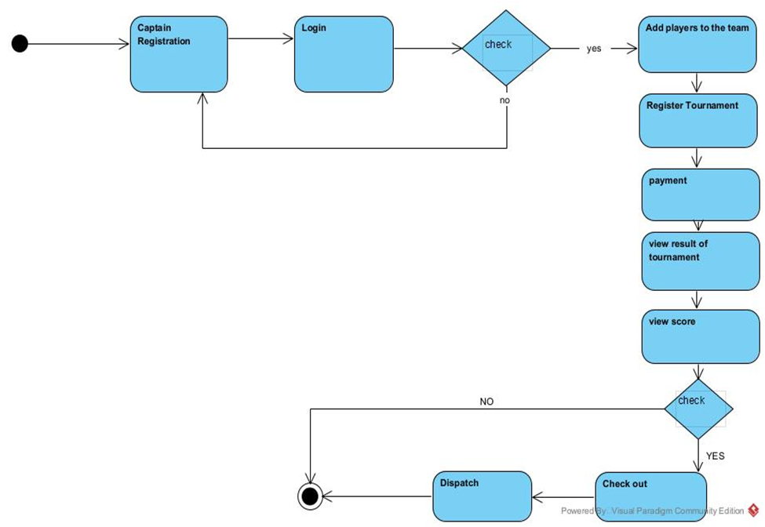

STATE DIAGRAM

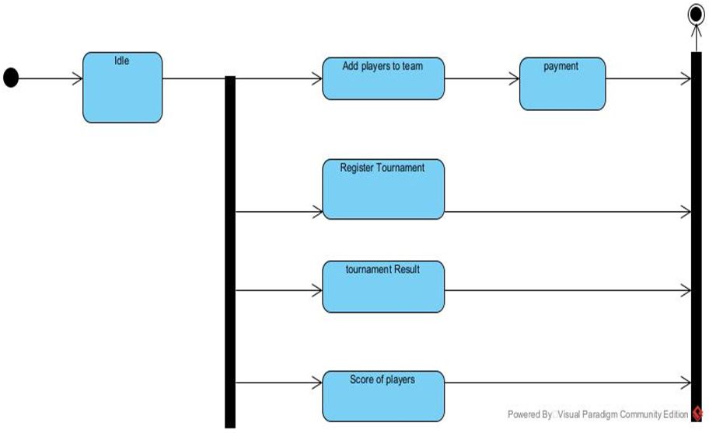

CLASS DIAGRAM

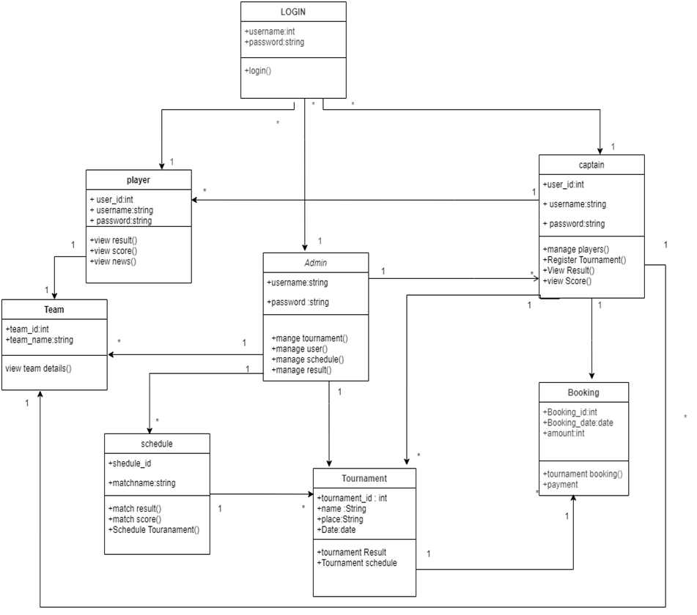

OBJECT DIAGRAM

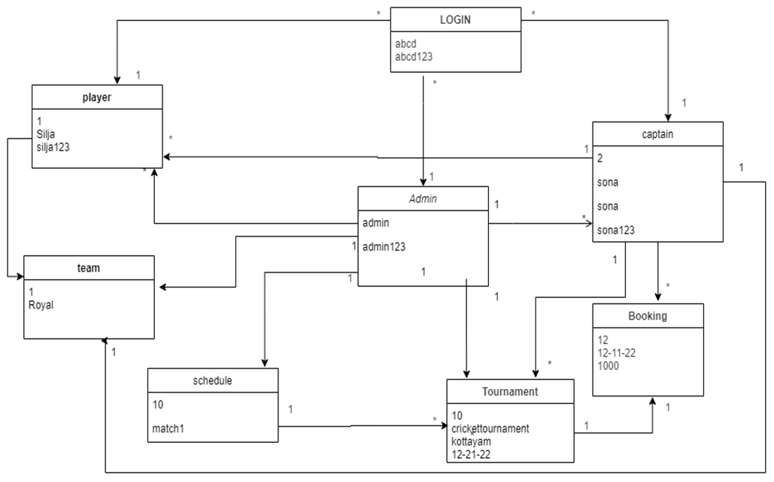

SEQUENCE DIAGRAM

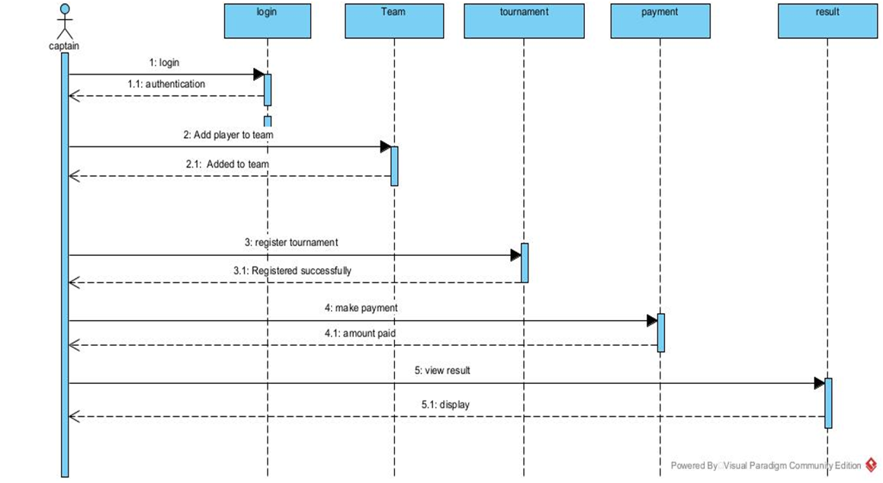

# COMPONENT DIAGRAM

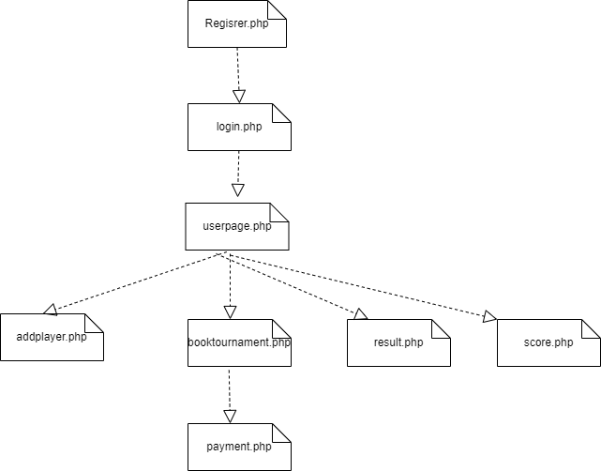

DEPLOYMENT DIAGRAM

